# Supervised Learning Algorithms



<https://www.youtube.com/watch?v=SrZ6vifbmdc&list=PLWPirh4EWFpEjbNicXUZk0wrPBzBlAlU_&index=2>



We provided **labeled data (training data with output).** Output means labeled data. Here, input variable is different balls. Output is their names. We train our model based on these labeled data. When we provide new input (a ball), model will predict the type of the ball.















If data set is not good, then it will give wrong predictions.

## KNN (K Nearest Neighbor) Algorithm (classification and regression)

KNN can be used for both classification and regression.







If I choose k=3, a new variable will belong to rectangle category because there are 2 rectangles and 1 triangle in that circle.

If I choose k=7, a new variable will belong to triangle category because there are 4 triangles and 2 rectangles.

So, choosing the right value of k is very important. The process of choosing the right value of k is a process called **Parameter tuning**.



Odd value of k is selected to avoid the tie breakers.



Let’s say, k = 5. Now, we have to find the distance between a new data point and given data points.



We can calculate the distance between two data points using Euclidean Distance formula.



Because K=5, we take 5 nearest data points. Because there are 3 data points from category A are nearest compared to 2 data points from category B, new data point belongs to Category A.



It’s a lazy algorithm. So, it works well when dataset is small.



When to use KNN?

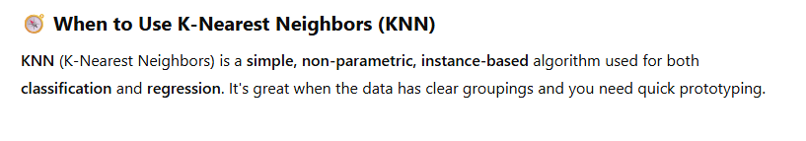

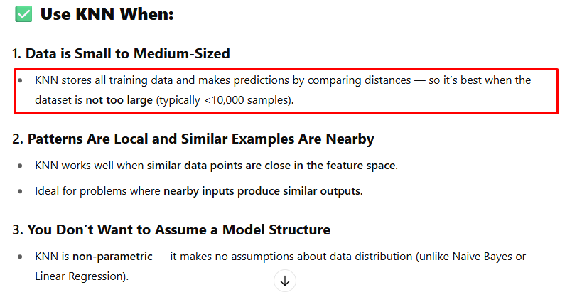

When to use KNN vs Logistic Regression?

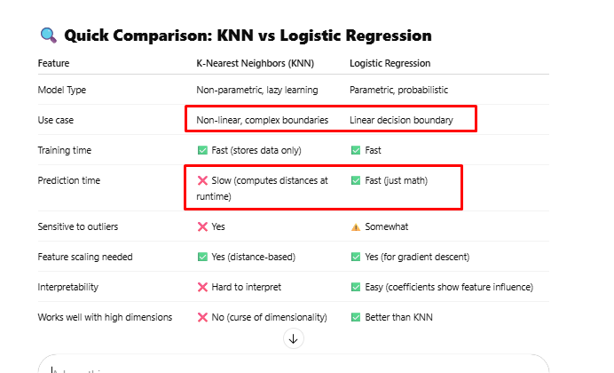

When to use KNN vs Linear Regression?

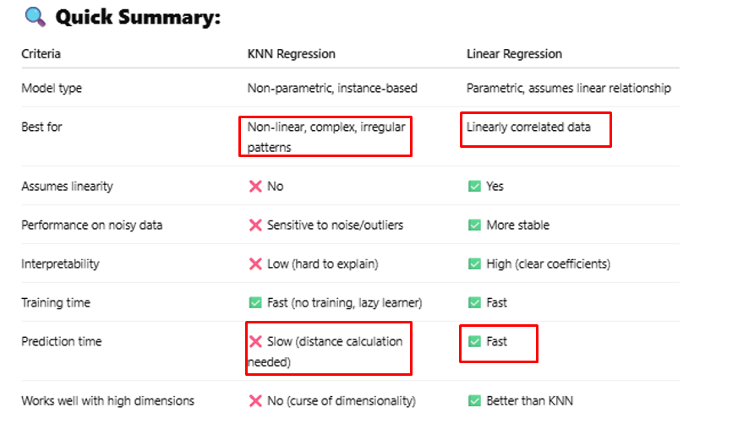

### How to choose K-value?

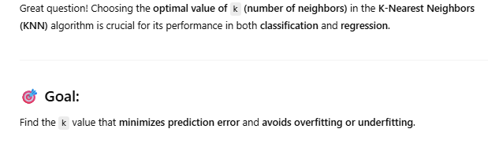

#### Elbow Method

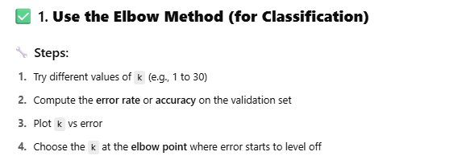

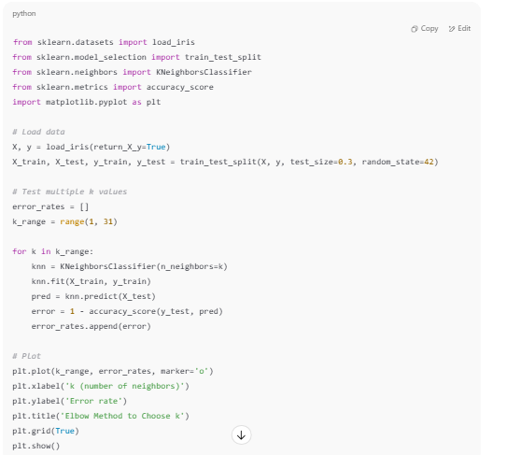

#### Cross-Validation Method

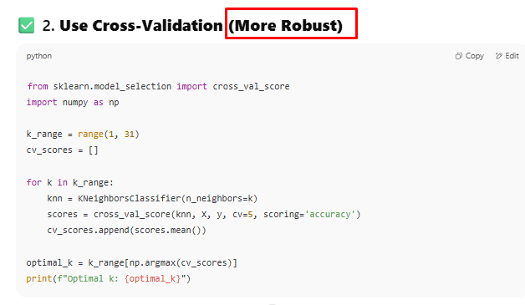

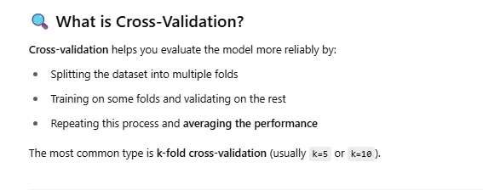

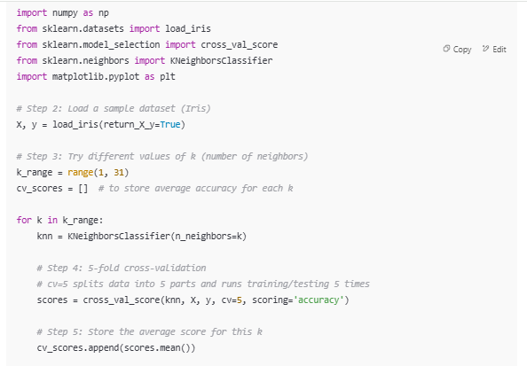

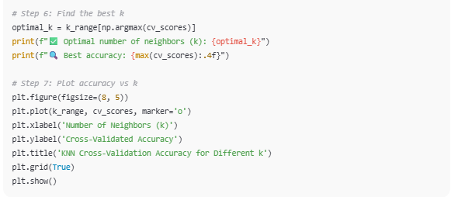

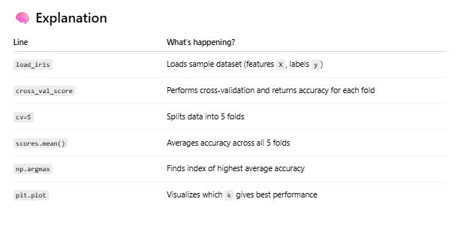

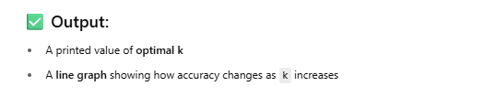

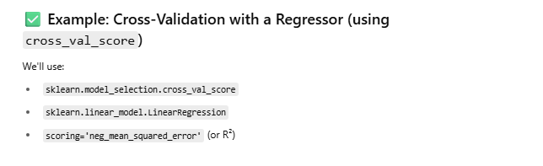

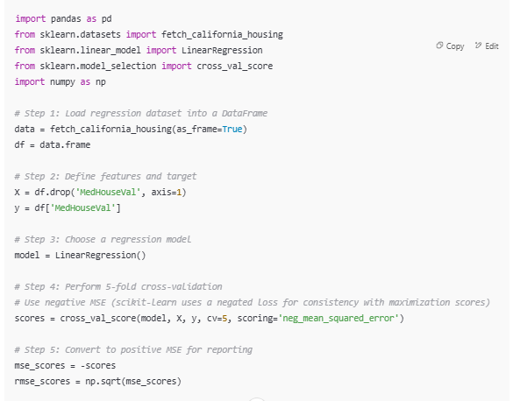

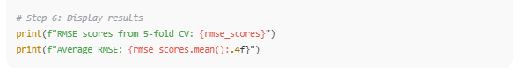

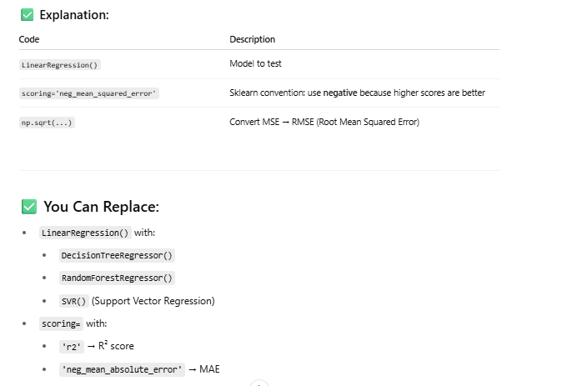

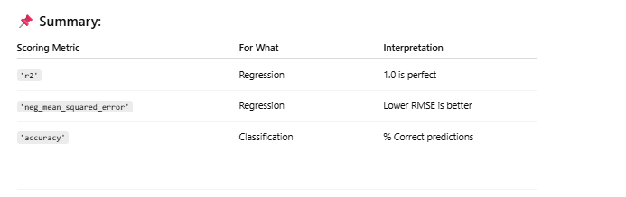

#### Heuristic Rule Method

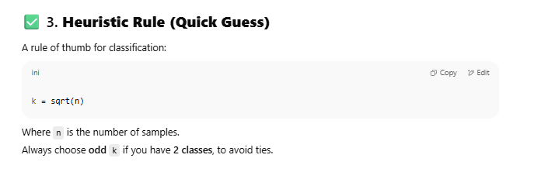

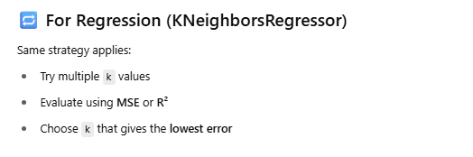

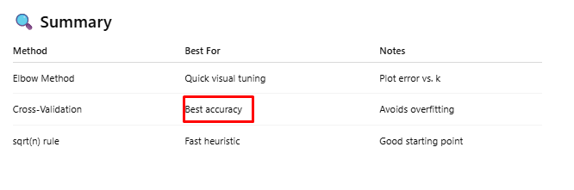

## Decision Tree Algorithm (classification and regression)

Decision Tree can be used for both classification and regression.







It is used for both Classification and Regression, but it works better for Classification.





Leaf node carries the final decision.



Entropy (unpredictability) is high at the beginning of the tree.















Entropy and Information Gain are calculated based on mathematical formula. **Variable that has minimum entropy is chosen as a root node.**

**Entropy** is a metric that measures the randomness or uncertainty in a dataset.

Entropy is a measure of how difficult it is to draw conclusions from a set of information. **A higher entropy value indicates a more random dataset, while a lower entropy value indicates a more predictable dataset.**

The goal of reducing entropy is to create a model that can make more accurate predictions. Entropy is a key component of decision tree algorithms, which use entropy to identify the best splits in a dataset.

<https://www.youtube.com/watch?v=CWzpomtLqqs&t=113s>



Let’s understand **ID3 (Iterative Dichotomiser 3)** algorithm for Decision Tree. You can use Random Forest algorithm also.



You have to calculate Entropy and Information Gain to choose the root node.





There are 5 Yeses and 9 Nos in the dataset. There are total 14 records in dataset.

We will represent Yes with + sign and No with – sign.







Information Gain of all 4 variables



**Information Gain of Weather is maximum, so that will become a root node**.

Now, Weather can be Sunny, Cloudy or Rainy. There are only 5 rows for Sunny.



Under Sunny, Now calculate the entropy of

* Temperature
* Wind
* Humidity











To choose every next node, you need to calculate its information Gain.

Random Forest Algorithm



It is an extension of decision tree. Forest means group of trees. Here, group of many decision trees.

Random means randomly selected data and variables.

**Ensemble learning** means making the final decision from group of decision trees (not one decision tree). **Single decision tree had a problem of overfitting will be removed in Random Forest Tree Algorithm**. **Overfitting** means when you create a decision tree from training data, it gives perfect output, but it fails for test data.



We will create many decision trees from random data and random attributes. E.g. you have a bucket of emails. Take 100 emails and a few attributes and create first decision tree, then put those 100 emails back to bucket. Now, take 100 emails again and a few attributes and create second decision tree. Now, put those 100 emails back to the bucket again and choose random 100 emails again with random attributes and create another decision tree.

You created 3 decision trees from training data.

Now, pass test data to these trees. If two decision trees gives a result ‘SPAM’, then majority wins and that email should be considered as SPAM.

In case of regression, take the average of the resulting number generated by each of these decision trees.

When to use Decision Tree/Random Forest?

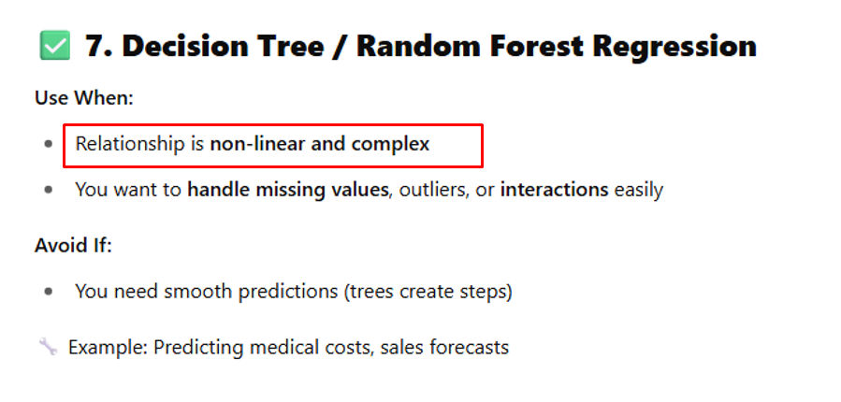

## Linear Regression Algorithm (Regression)

Linear regression algorithm can be used for only Regression.





Dependent variable means an output variable.

Independent variables means input variables.

















Regression line should ideally pass through the mean of x and mean of y.





Purple dots are predicted dots of Y for every X and green dots are actual dots. **Distance between actual and predicted dots is called Error. Sum of squares of these distances should be the least for the best predictions.**





These are different ways to calculate the error in linear regression.

Root Mean Square error is called RMSE. Watch

<https://www.youtube.com/watch?v=XifOXgdl7AI>

**Mean Absolute Error (MAE)**



y – y` is an error. Absolute means a |y-y`|. Its average |y-y`| / total data points(n).





#### Mean Square Error (MSE)



If there are outliers, this squared value will be very big. It will be too far from the actual error.

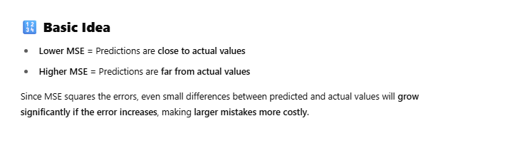

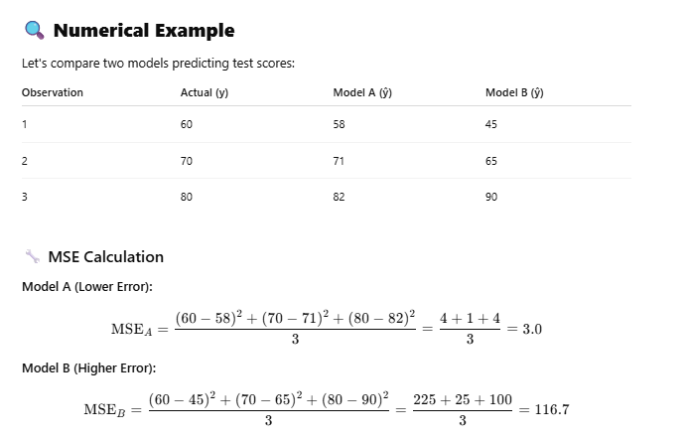

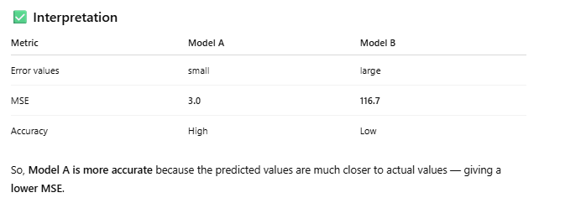

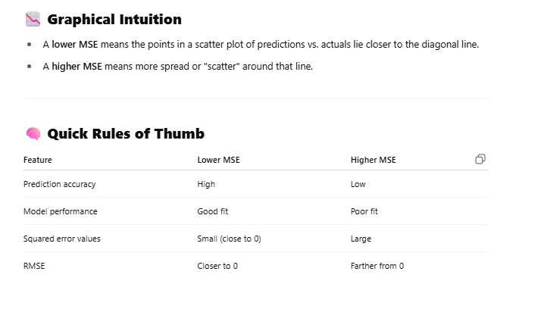

#### Root Mean Square (RMS)







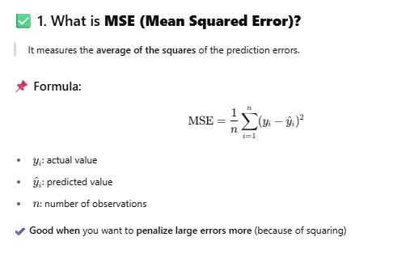

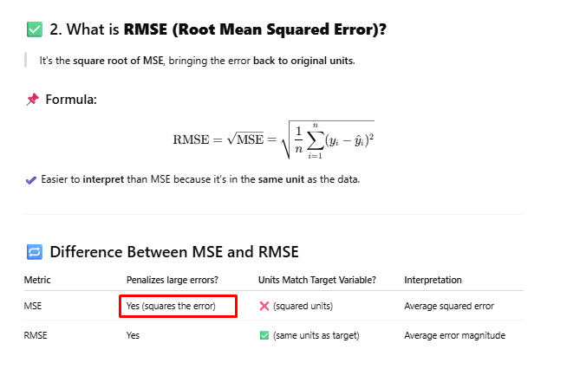

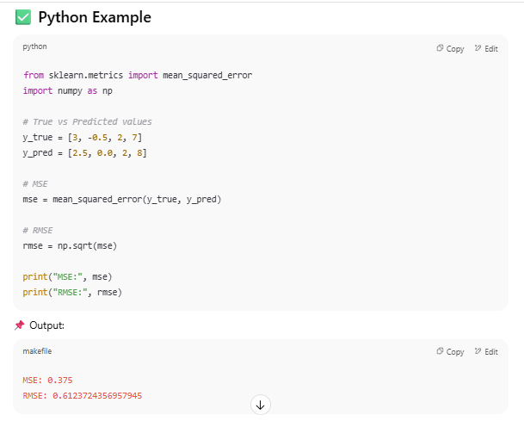

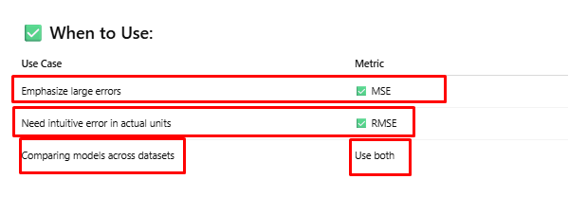

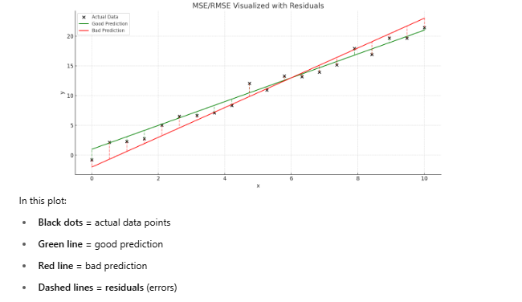

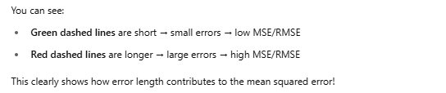

#### R square and Adjusted R square

<https://www.youtube.com/watch?v=w2FKXOa0HGA>

Read ‘Udemy Statistics Document’

#### Multiple Linear Regression





When to use Linear Regression?

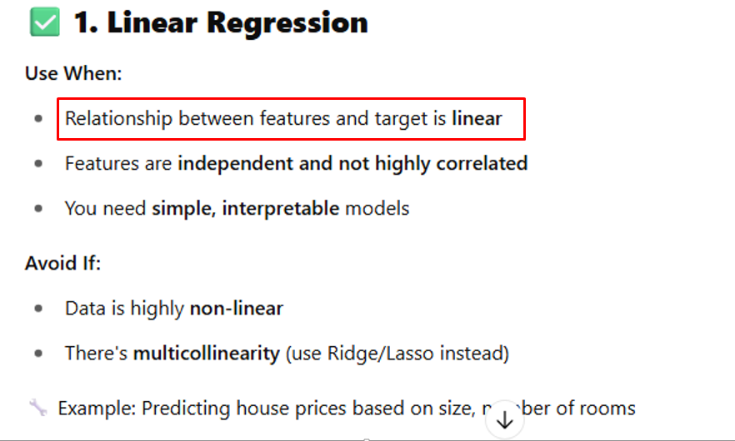

## Polynomial Regression

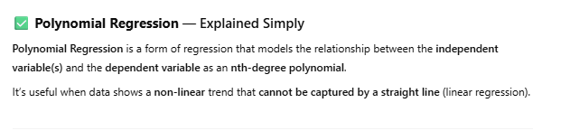

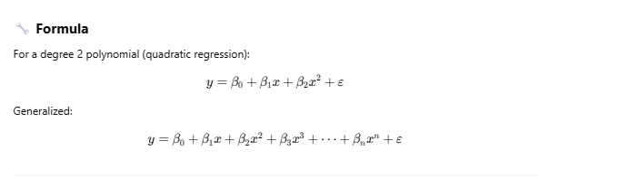

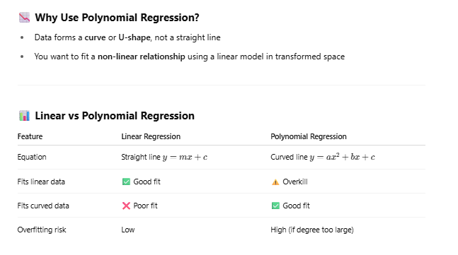

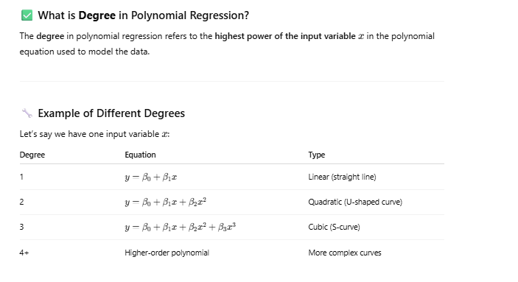

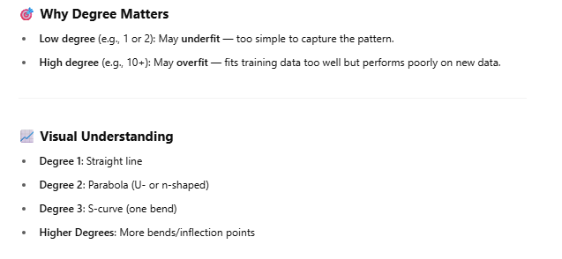

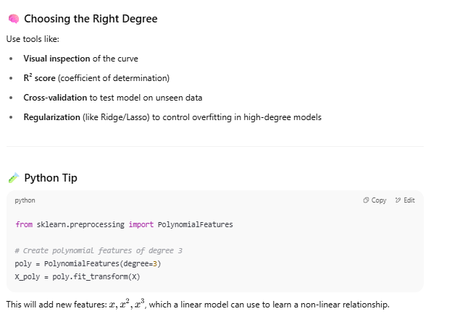

<https://www.geeksforgeeks.org/machine-learning/python-implementation-of-polynomial-regression/>

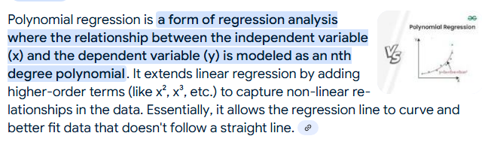

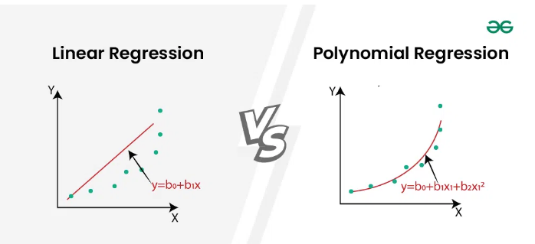

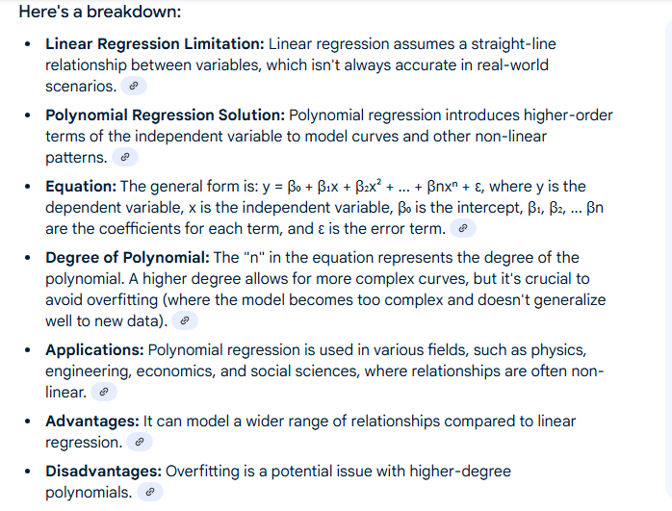

## Support Vector Machine (SVM) Algorithm (classification and regression)

Can be used for both classification and regression.

You can watch

<https://www.youtube.com/watch?v=xLkk6MUrvrw> (part 1) and <https://www.youtube.com/watch?v=0MJTaPoHv-g> (part 2) and

<https://www.youtube.com/watch?v=owsAQ_fiwIw> (part 3).

<https://www.geeksforgeeks.org/machine-learning/support-vector-machine-algorithm/>



It is a part of Supervised Learning.







To divide these data points in two categories, we can draw any of the two lines as shown above, but green line is more preferable. Why?



Hyperplane is also called Decision Boundary. Points touching to dotted lines are called support vectors.





To get an optimal hyperplane, we need the maximum margin. Haperplane with maximum margin gives us the best results.

What if our data points are in straight line? You can’t use the hyperplane to separate the two categories.



Select the hyperplane that can give the maximum margin. Here, m2 > m1, so we will select the second hyperplane.



We will transform 1D plot to 2D plot and for that we need Kernel Function.



Now, we can use the hyperplane to separate the two categories.









We can transform 1D to 3D using kernel function. Now, we can use hyperplane.



For non-linear data, if you try to separate data with a linear line, you can’t separate them.

Kernel function converts low dimensional input to high dimensional input. E.g. in above picture, you are not able to draw a hyperplane to classify the data properly. In this case, you will give this data to Kernel function and it will convert that data to 2-D.

Similarly, you have 2-D data in circular form. By drawing a linear hyperplane, you can’t classify them. You have to give this data to Kernel function and it will convert it into high dimensional input data (3-D) data.













Look at



When we start working on high dimensional input space, other algorithms start creating problems and we need to adjust them, but SVM automatically takes care of that.

One of the high dimensional input space is called a Sparse Document Vector.

Regularization parameter helps us in determining whether we are going to have bias or overfitting that we have to manage in many other algorithms, but svm naturally does it for us.



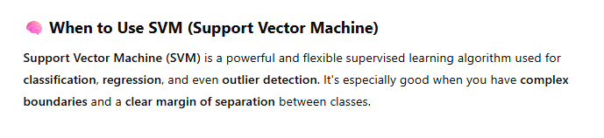

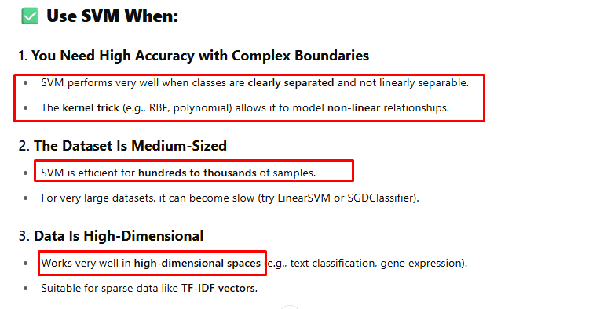

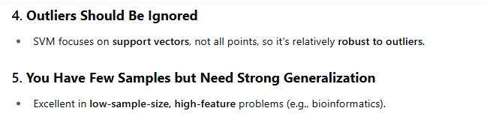

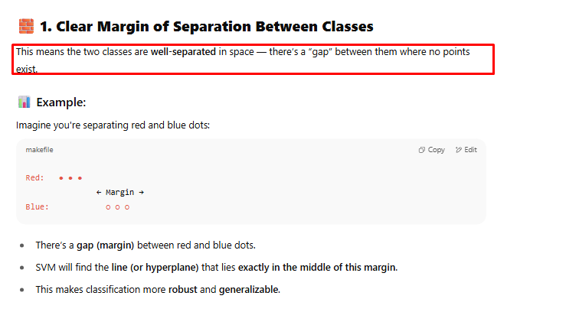

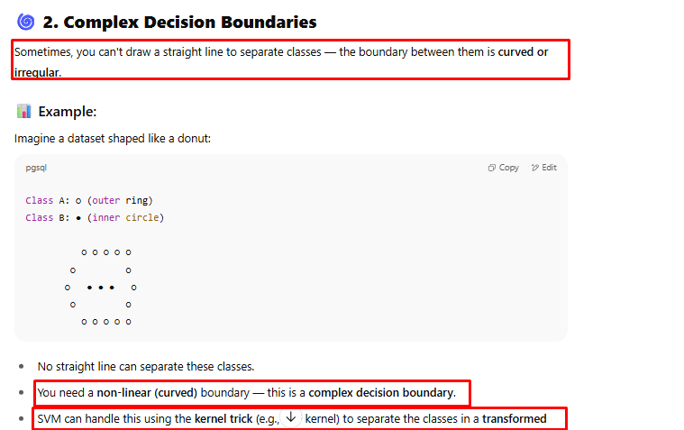

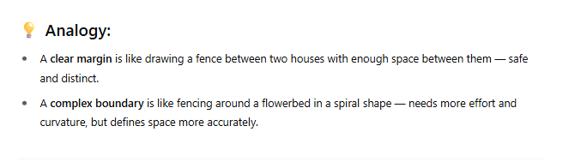

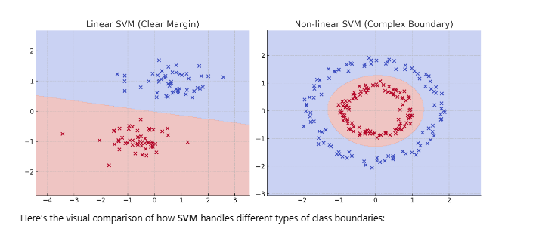

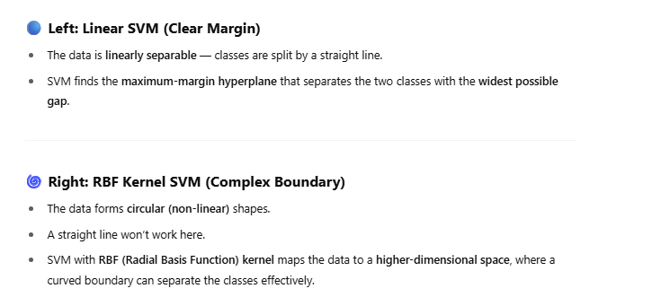

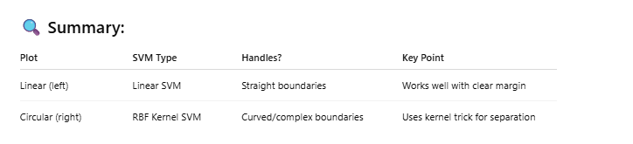

Different kernels explanation:

<https://www.geeksforgeeks.org/machine-learning/major-kernel-functions-in-support-vector-machine-svm/>

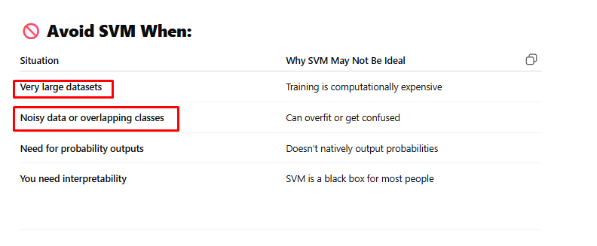

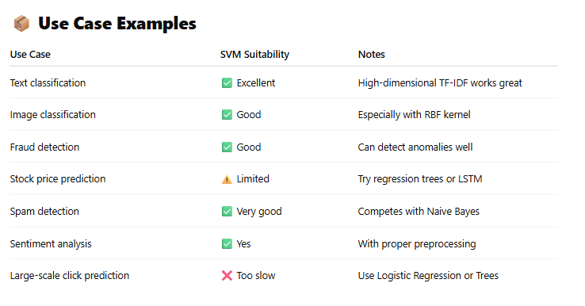

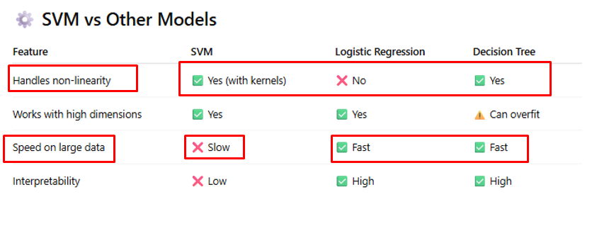

Even Linear Regression should be use when data is linear. For non-linear data, use either SVR(support vector regression) or Decision Tree/Random Forest.

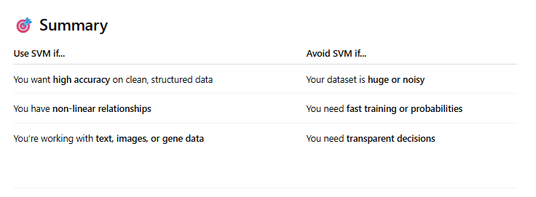

When to use SVR(Support Vector Regression) vs Linear Regression for linear data?

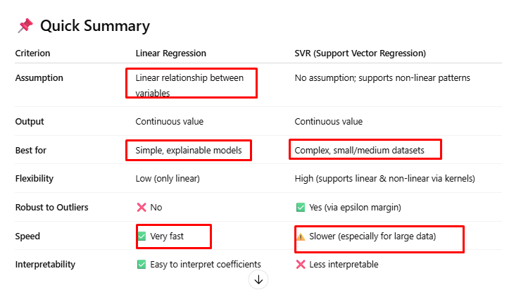

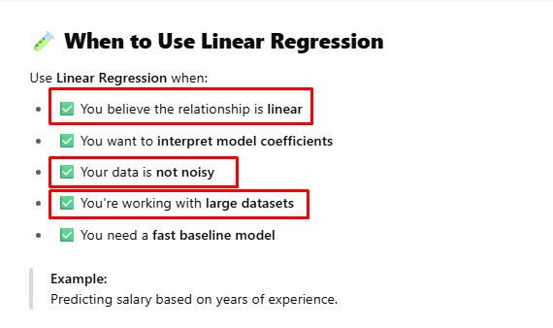

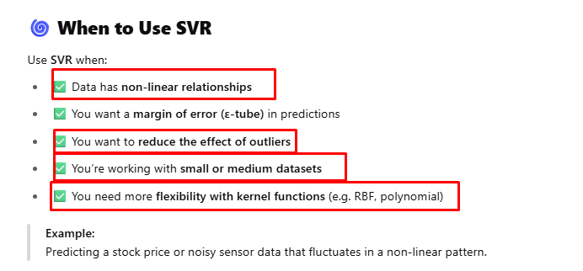

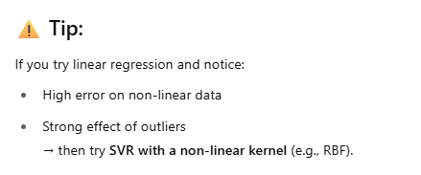

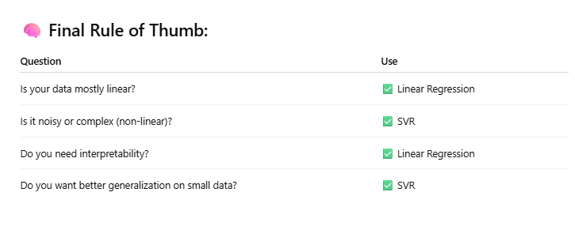

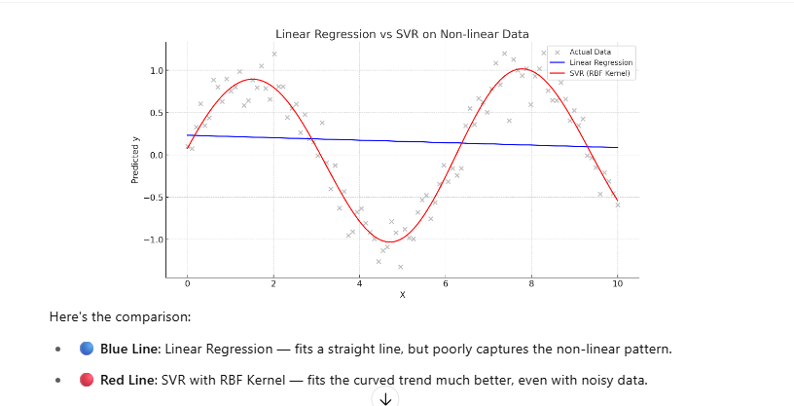

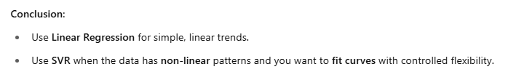

## Random Forest Algorithm (classification and regression)

Read ‘Decision Tree Algorithm’ first.













Which input variable will become a Root Node and other Decision Nodes is determined based on Entropy and Information Gain of that variable. Read ‘Decision Tree Algorithm’ to know more about it.









Choose random data and random features for creating different decision trees.

Now, replace repeating rows.



No, create a decision tree for each sample.







Now, you can pass new input data to these decision trees.



Two decision trees returns an output ‘Chinstrap’ and one decision tree returns an output ‘Adelie’. Majority wins.





## Naïve Bayes Algorithm (classification)

Naive Bayes is a probabilistic algorithm that's typically used for **classification problems**. Naive Bayes **can be used for regression, but it's not as effective as other methods**.





It’s a probability based algorithm. Probability of output variable’s value is compared with every feature (input variable) separately. **This algorithm assumes that input variables are independent of each other.**







4 out of 12 face cards in a deck can be a king card. So 1/3.

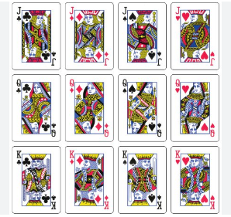

Based on Outlook, Humidity and Wind, we will decide whether to play outside or not. So, Play is our output variable.



Now, create frequency table for each input variable and output variable.











Our outcome will be ‘Yes’, we can play outside.









### When to use Naïve Bayes?

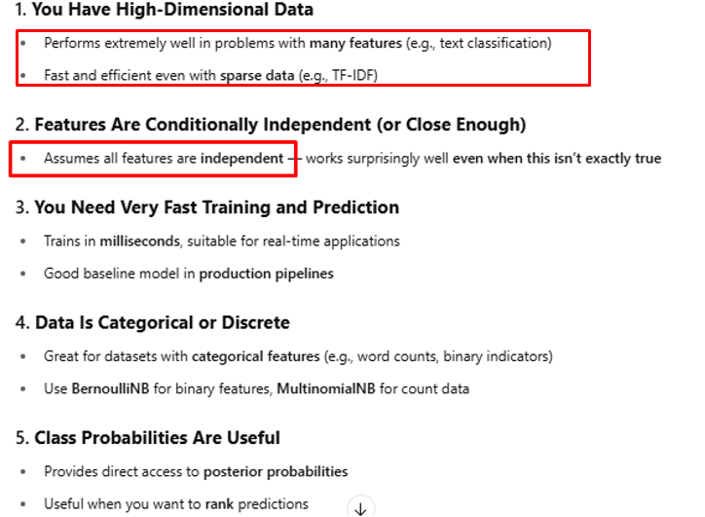

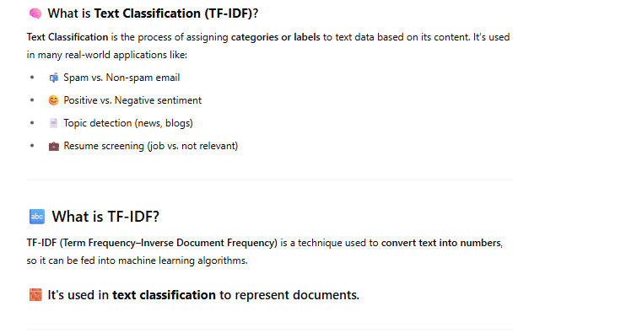

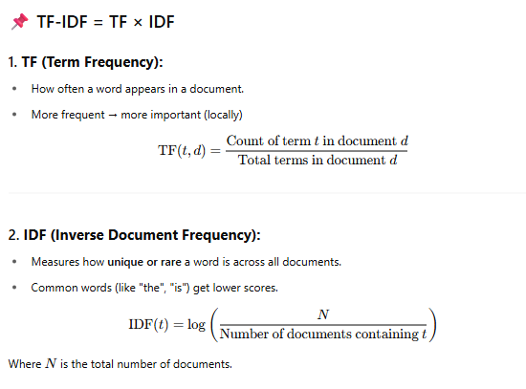

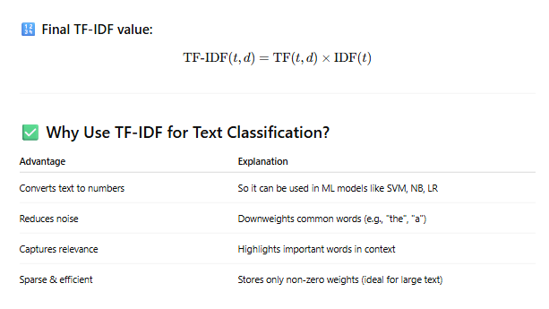

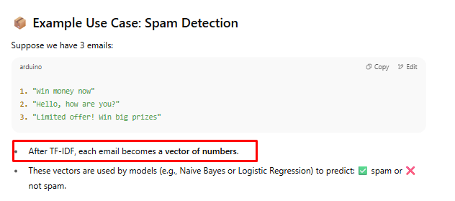

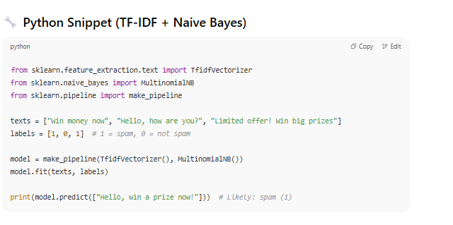

### Different Naïve Bayes Models

#### Gausian Model

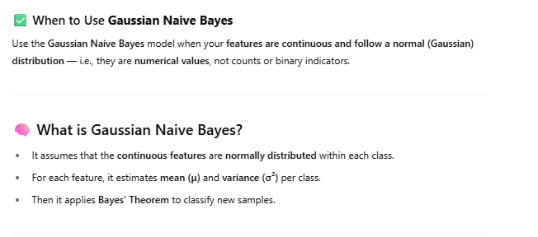

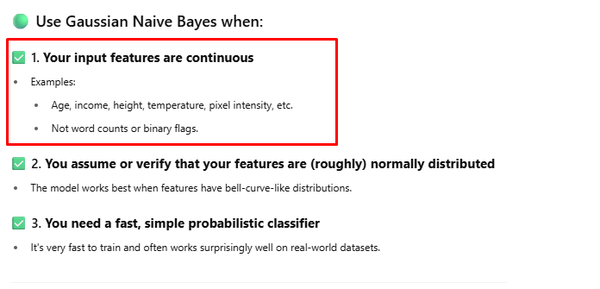

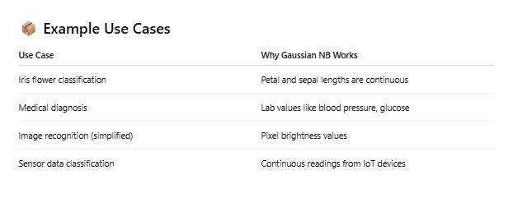

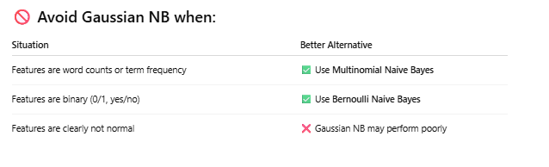

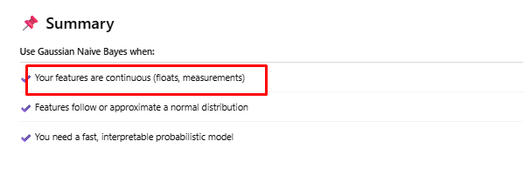

#### Bernoulli Model

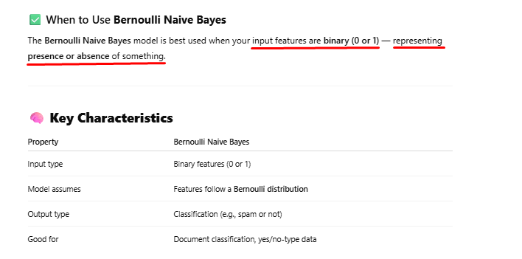

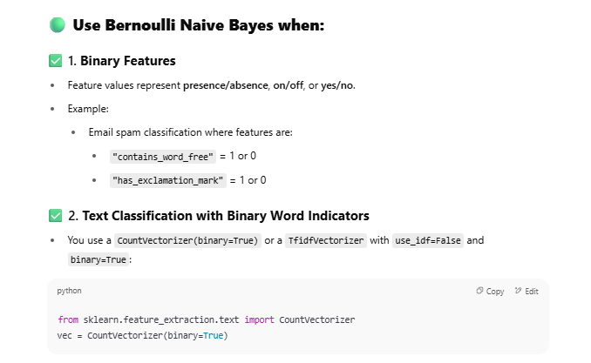

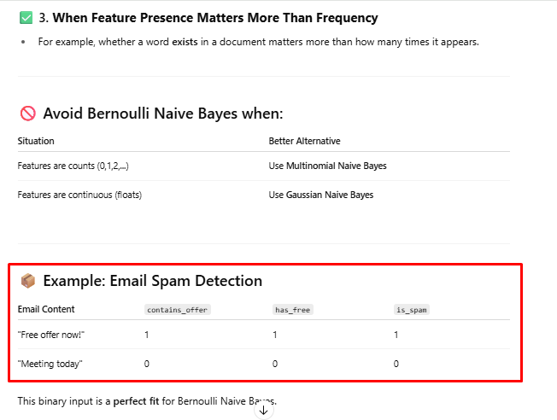

#### Multinominal Model

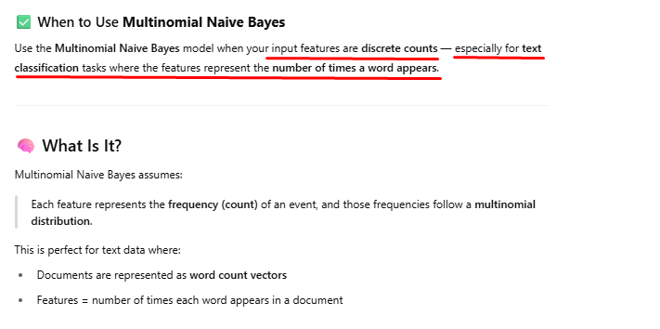

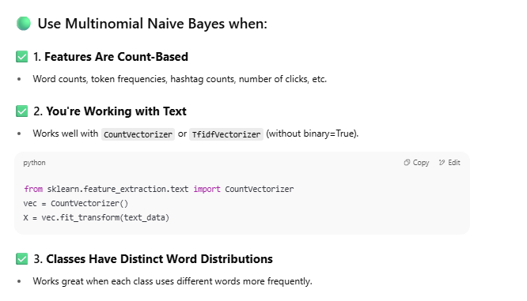

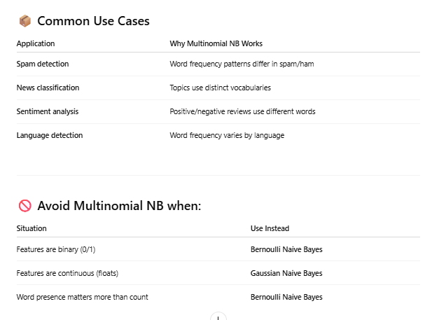

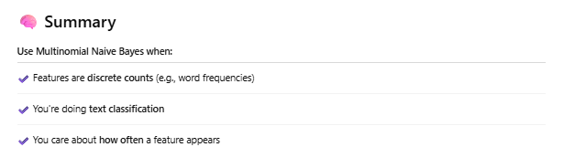

### When to use Naïve Bayes vs Logistic Regression?

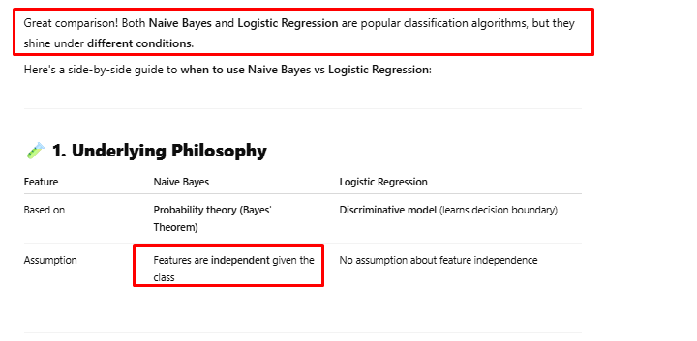

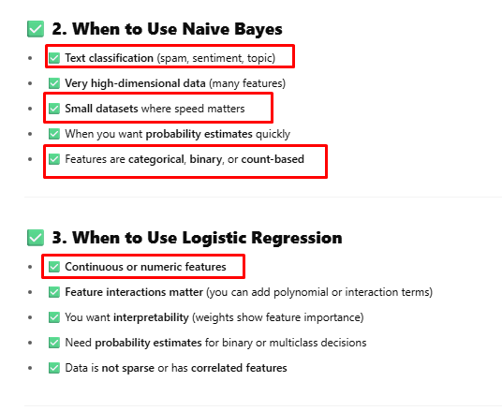

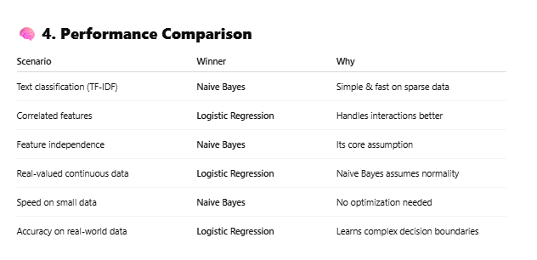

## Logistic Regression Algorithm (Classification)



Logistic Regression is a binary classification.







In classification problem, there are only two values of output variable (Y), 0 or 1. So, the data points for different values of independent variable (X) and 0/1 of depended variable (Y) can be plotted as shown above.

Logistic regression is based on a **Sigmoid** curve that can be drawn as shown above by connecting all data points. If predicted outcome is above the threshold value, then an event is going to happen, otherwise it won’t happen. Y is the outcome variable. S-curve is called Sigmoid curve that is derived from Sigmoid function.





Change in one variable causes the proportional change in another variable. So, outcome is not categorical.



Depending on Employee rating, we can predict the exact salary hike (continuous number). But you can’t predict whether the employee will have promotion or not (categorical value). For that, you have to use Logistic Regression.

For Logistic Regression, Sigmoid function is used. Sigmoid function represents the Sigmoid curve.



Calculation of B0 and B1 in Linear Regression is different than that of Logistic Regression. Maximum Likelihood Method is used for Logistic Regression. It is a very complex mathematical process.

<https://www.youtube.com/watch?v=r8OjlgWpAI0>

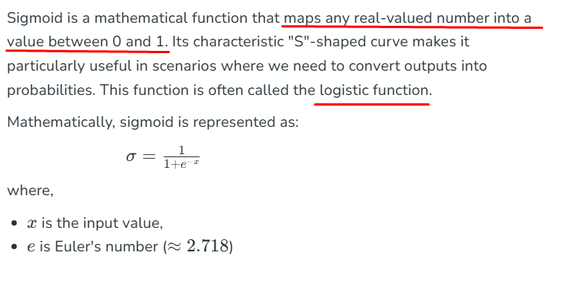



Sigmoid function. It will always give a value in between 0 and 1.



a0 and a1 are calculated based on maximum likelihood method, cost optimization method and gradient decedent method. These are very complex mathematical formulas.



